**Pizza Cafe Billing System**

* Class diagram

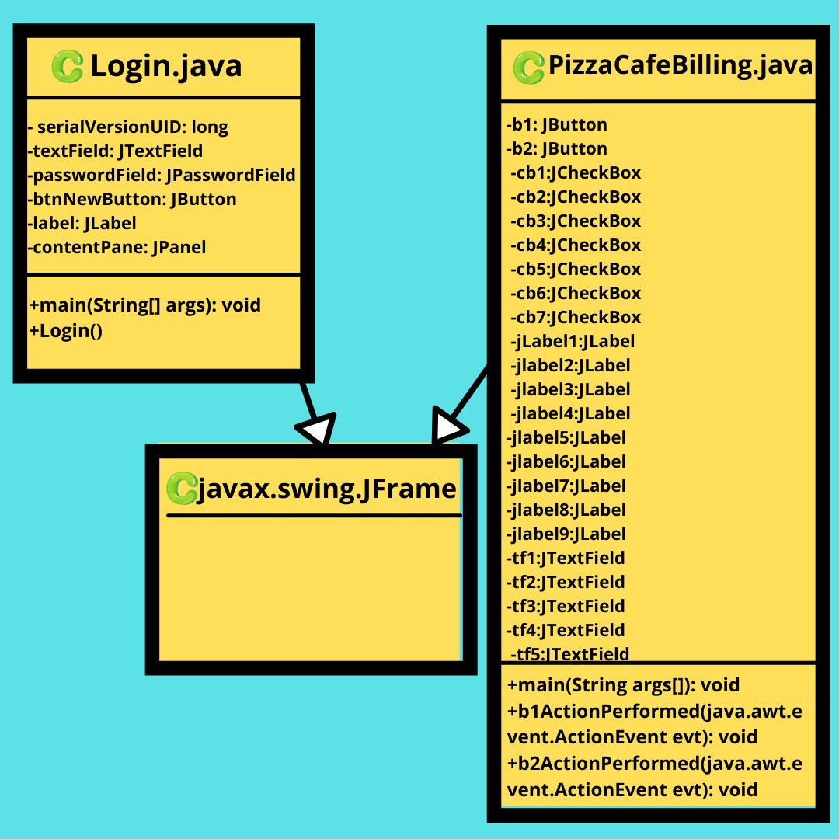

* Architecture-diagram

Java Netbeans XAMPP Database: My SQL

(local host)

(connectivity) (connectivity)

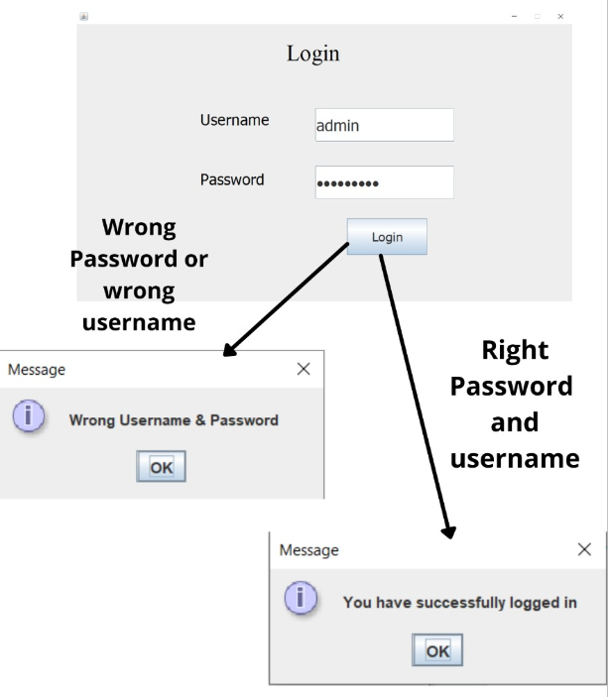 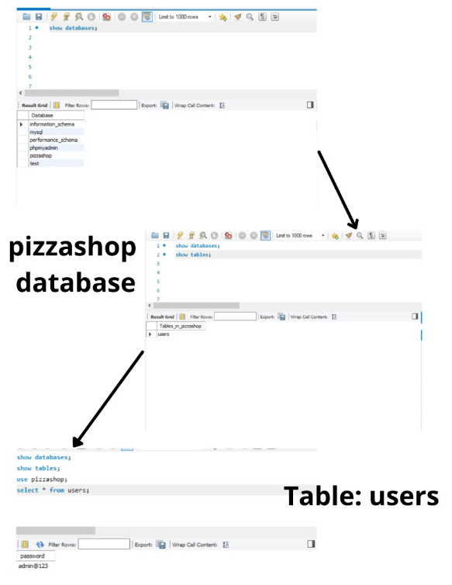

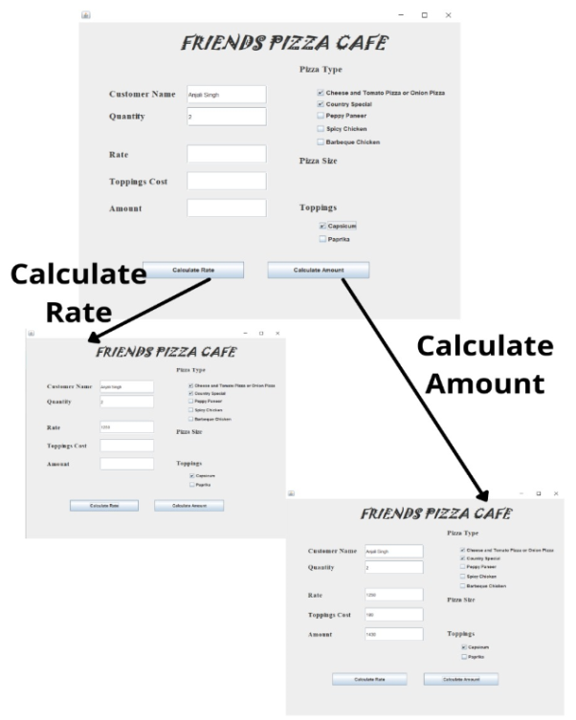

* User-case – diagram

Customer

Amount

Topping Cost

Rate

Toppings:

1. Capsicum

2. Paprika

Pizza Size

Large/Medium /Small

Pizza type:

1. Cheese/Tomato/Onion

2. Country Special

3. Peppy Paneer

4. Spicy Chicken

5. Barbeque Chicken

Quantity

Customer – Name

CHEF

Login Page

Admin’s User ID & Password

ADMIN